# **Week-05-Nested Loops - while and for, Jumps in Loops**

Week-05-01-Practive Session-coding

ROLL NO: 241801296

NAME: THARUNIKA R

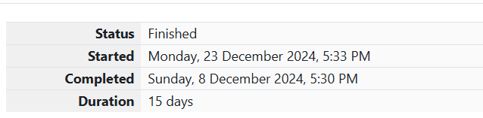

Q1) Write a program that prints a simple chessboard.

Input format:

The first line contains the number of inputs T.

The lines after that contain a different value for size of the chessboard

Output format:

Print a chessboard of dimensions size * size.

Print W for white spaces and B for black spaces.

Sample Input:

2

3

5

Sample Output:

WBW

BWB

WBW

WBWBW

BWBWB

WBWBW

BWBWB

WBWBW

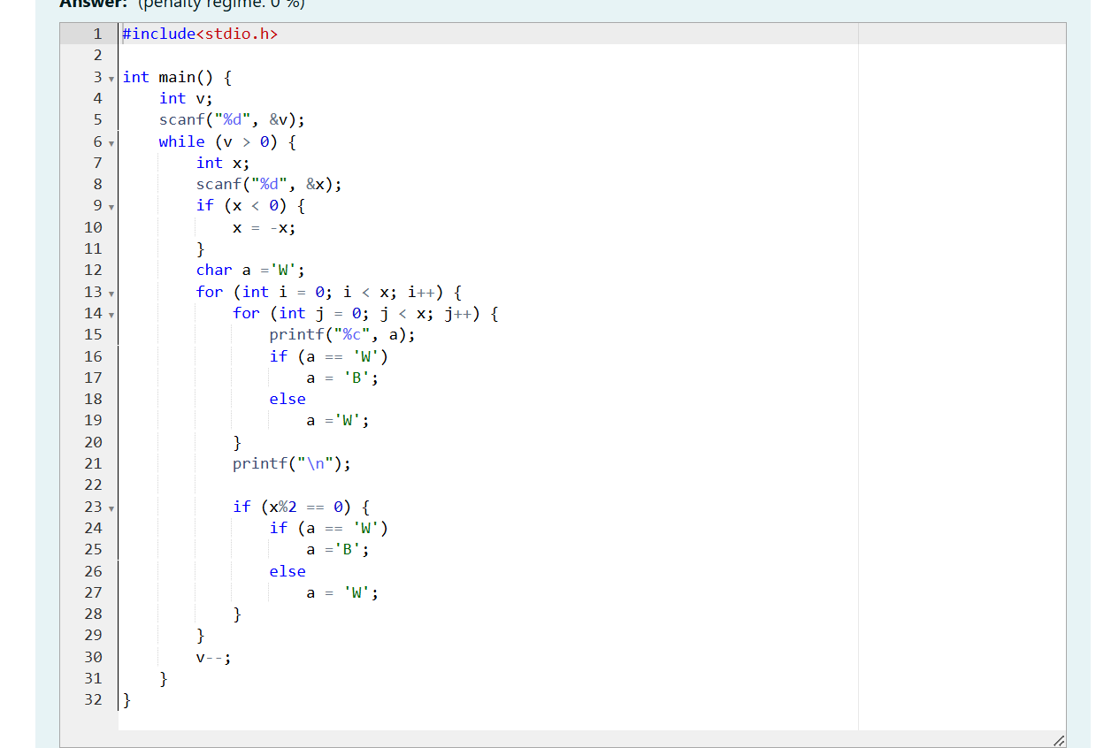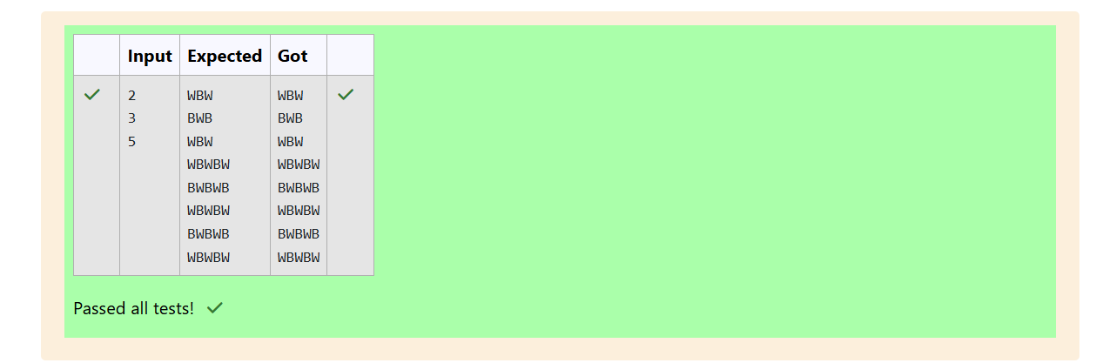

Q2) Let’s print a chessboard!

Write a program that takes input:

The first line contains T, the number of test cases

Each test case contains an integer N and also the starting character of the chessboard

Output Format

Print the chessboard as per the given examples

Sample Input:

2

2 W

3 B

Sample Output:

WB BW BWB WBW BWB

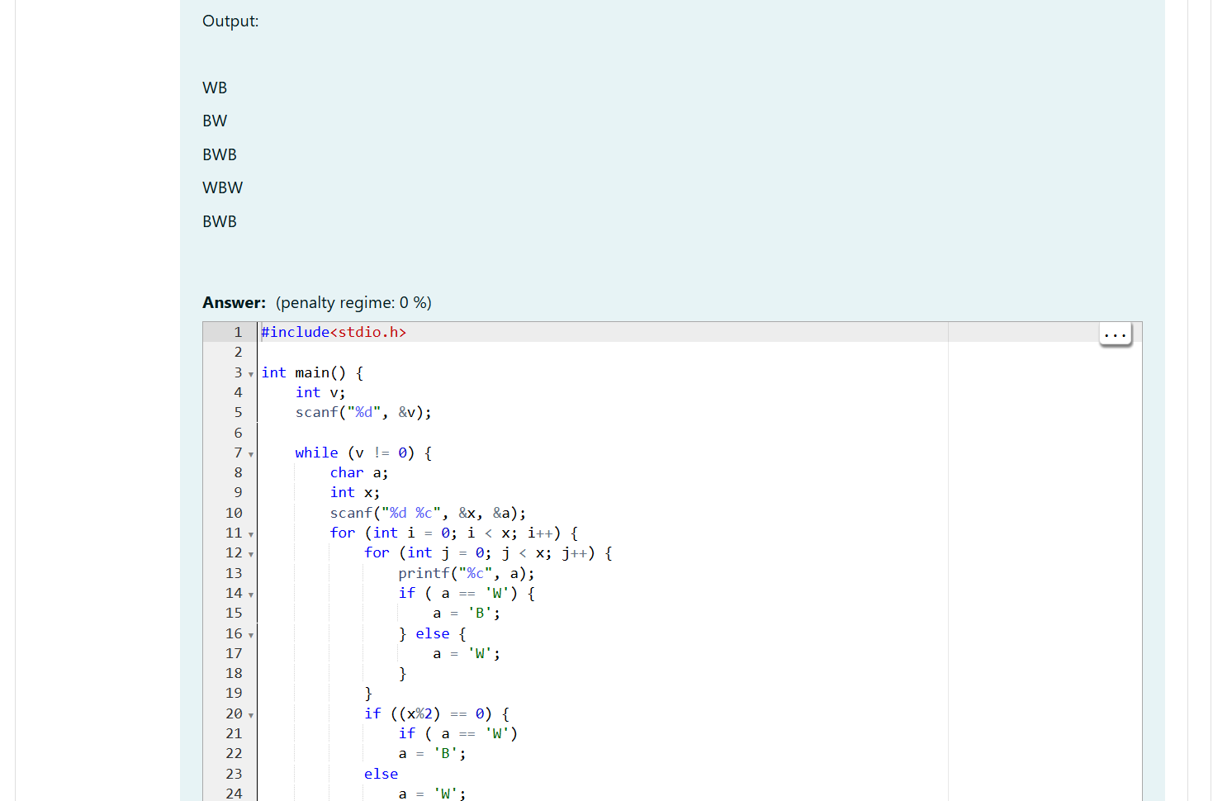

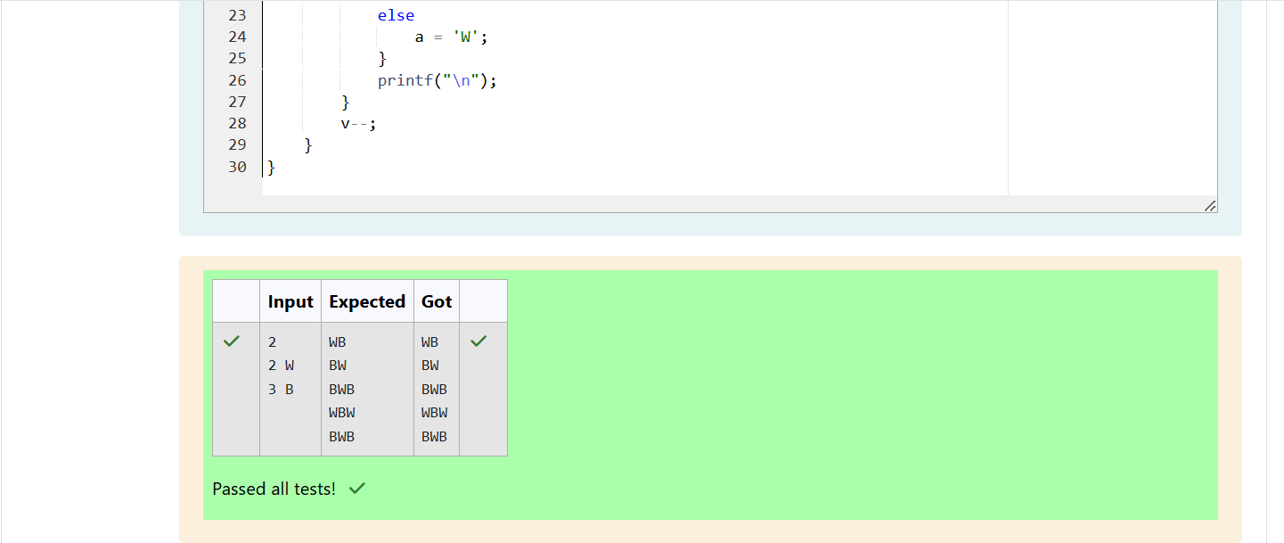

Q3) Decode the logic and print the Pattern that corresponds to given input.

If N= 3 then pattern will be:

10203010011012

**4050809

****607

If N= 4, then pattern will be:

1020304017018019020

**50607014015016

****809012013

******10011

Constraints: 2 <= N <= 100

Input Format

First line contains T, the number of test cases, each test case contains a single integer N

Output Format

First line print Case #i where i is the test case number, In the subsequent line, print the pattern

Sample Input

3 3 4 5

Sample Output

Case #1

10203010011012

**4050809

****607

Case #2

1020304017018019020

**50607014015016

****809012013

******10011

Case #3 102030405026027028029030 **6070809022023024025 ****10011012019020021 ******13014017018 ********15016

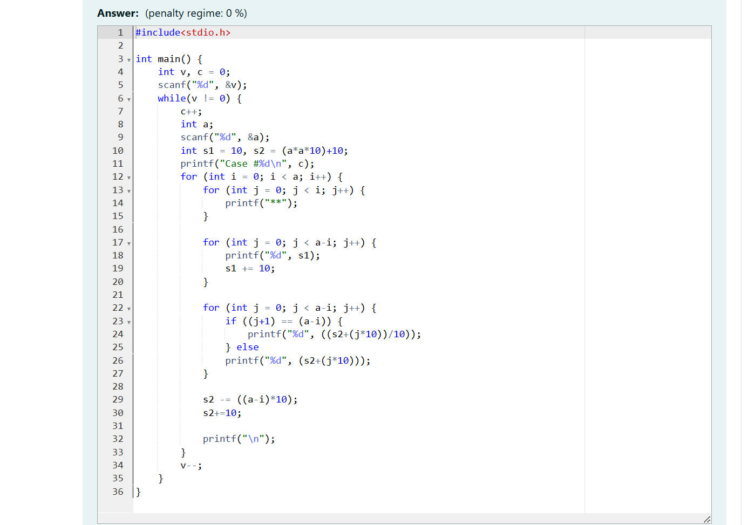

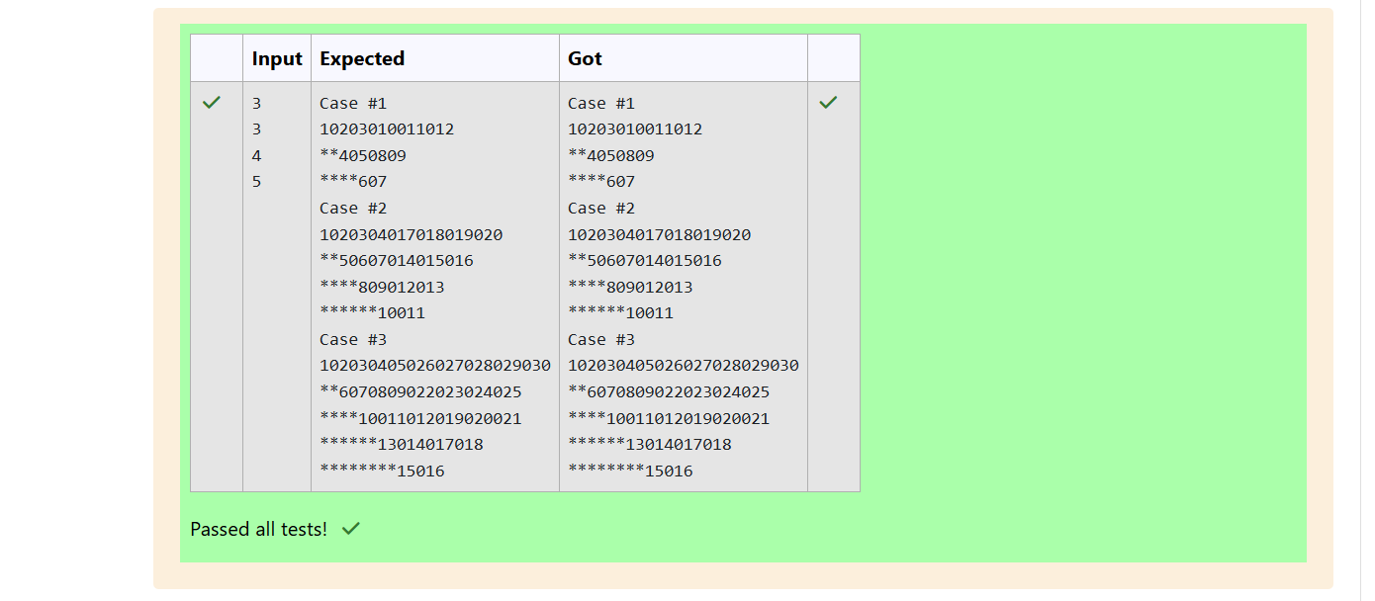

Week-05-02-Practive Session-coding

ROLL NO: 241801296

NAME: THARUNIKA R

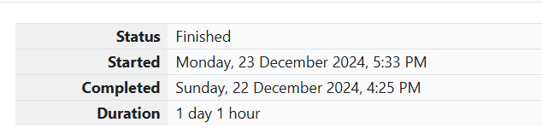

Q1)

The k-digit number N is an Armstrong number if and only if the k-th power of each digit sums to N.

Given a positive integer N, return true if and only if it is an Armstrong number.

**Note**: 1 <= N <= 10^8

**Hint**: 153 is a 3-digit number, and 153 = 1^3 + 5^3 + 3^3.

Sample Input:

153

Sample Output:

true

Sample **Input**:

123

Sample **Output**:

false

Sample **Input**:

1634

Sample **Output**:

TRUE

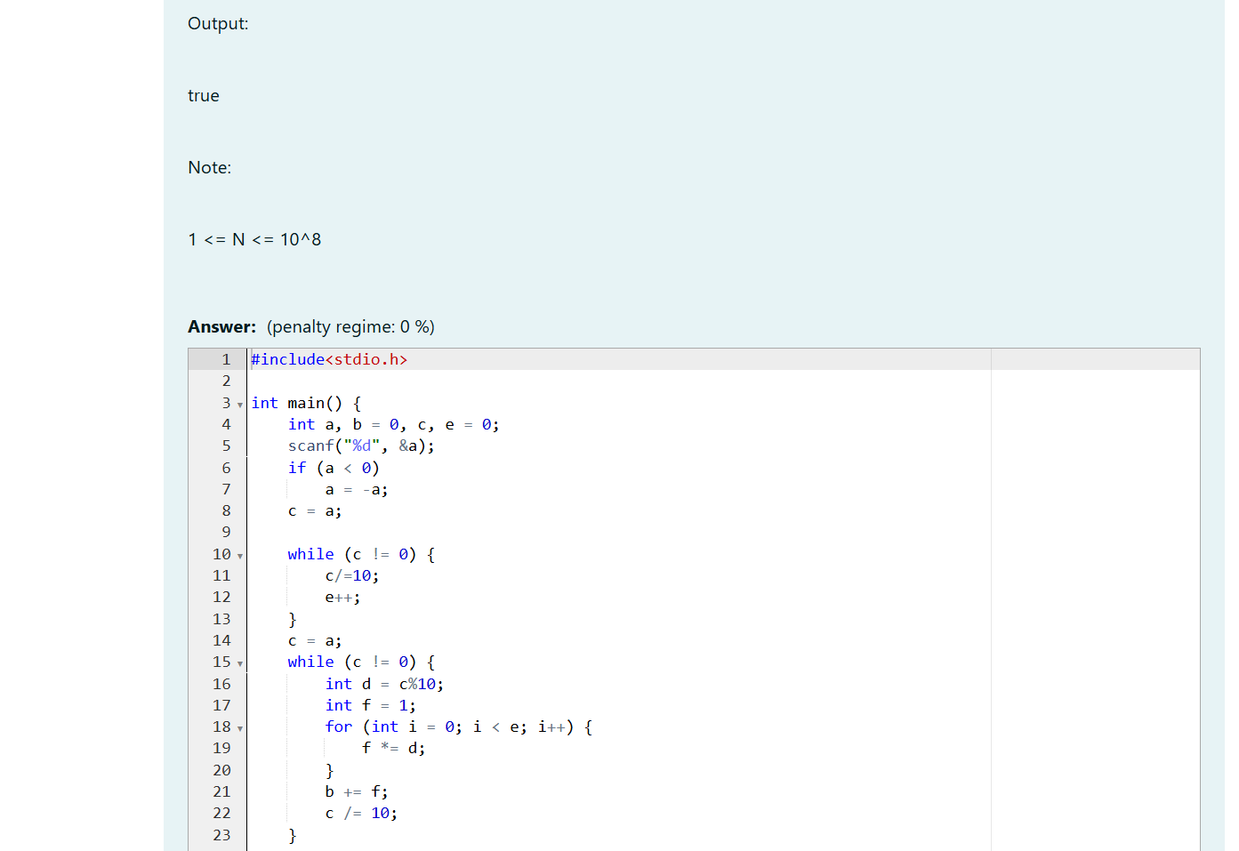

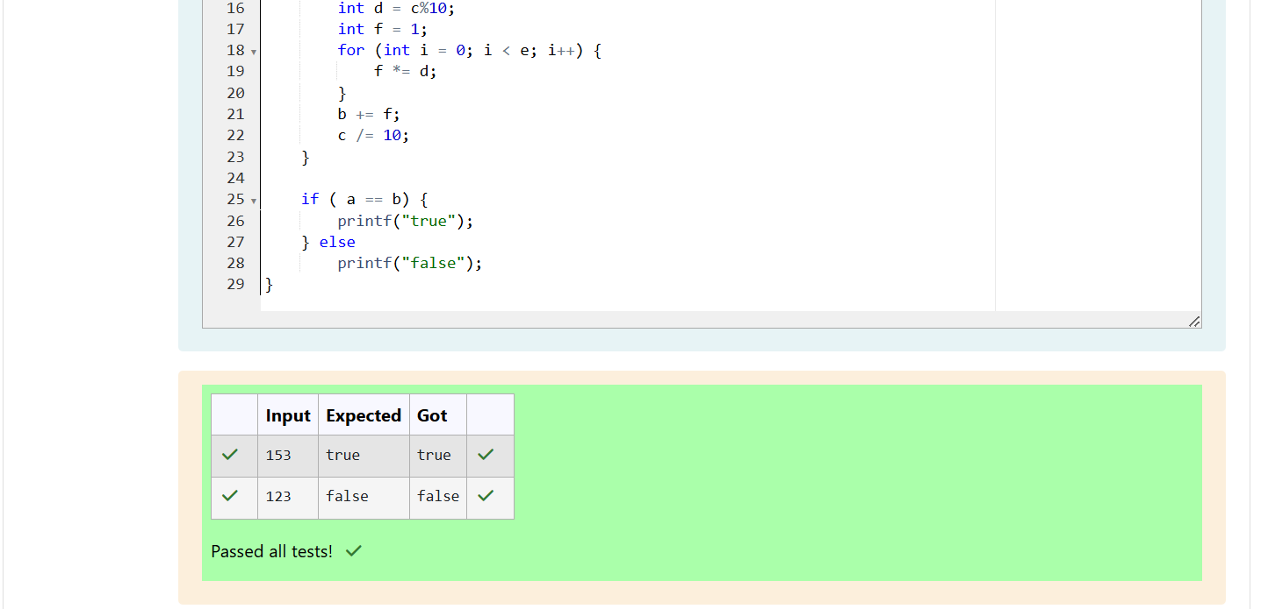

Q2)

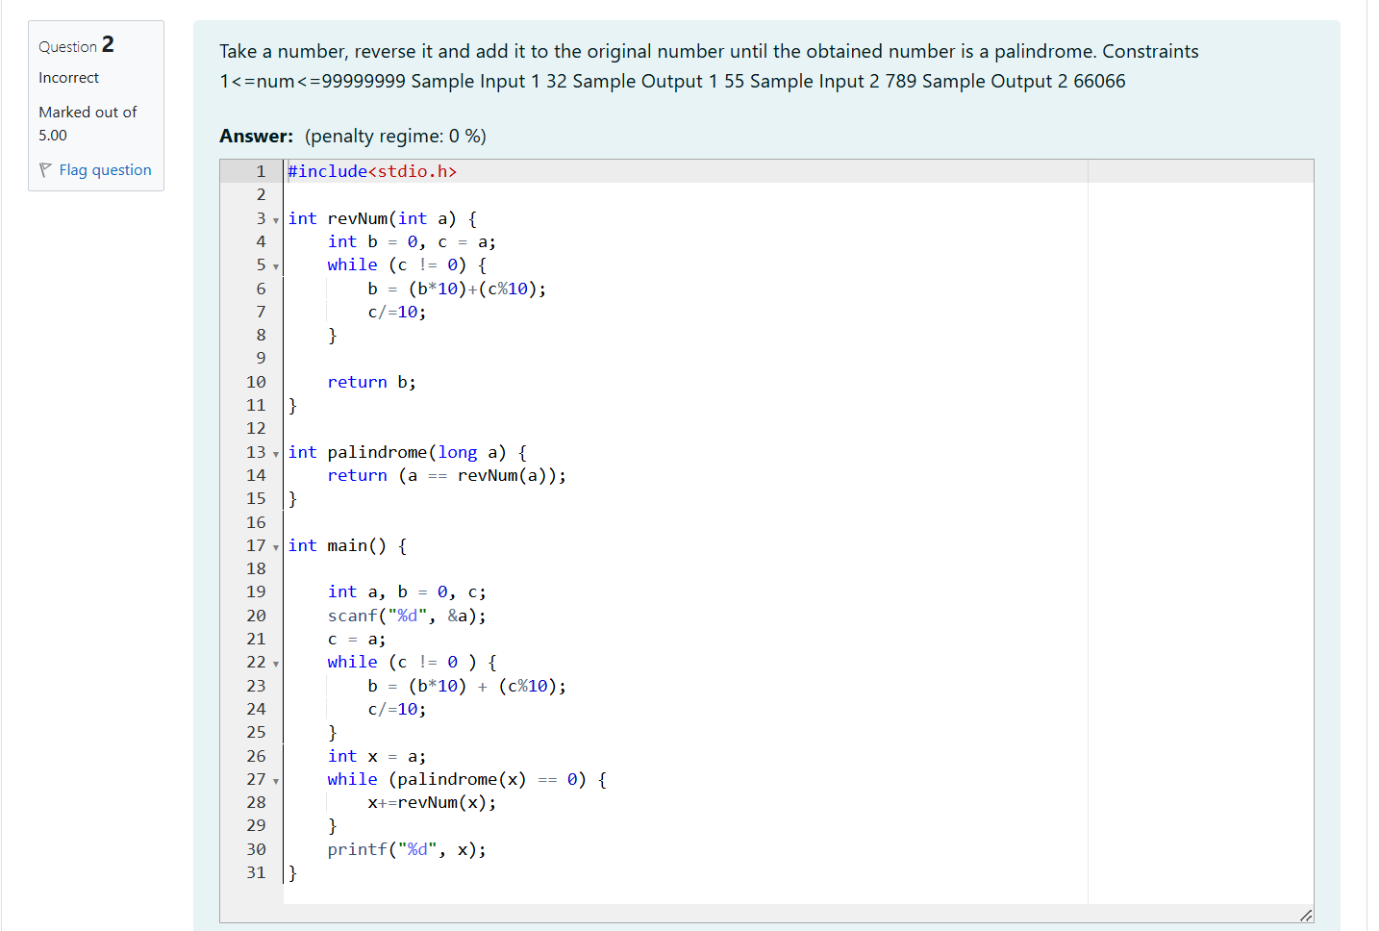

Q3)

A number is considered lucky if it contains either 3 or 4 or 3 and 4 both in it. Write a program to print the nth lucky number. Example, 1st lucky number is 3, and 2nd lucky number is 4 and 3rd lucky number is 33 and 4th lucky number is 34 and so on. Note that 13, 40 etc., are not lucky as they have other numbers in it.

The program should accept a number 'n' as input and display the nth lucky number as output.

Sample Input 1:

3

Sample Output 1:

33

